
Deccan Education Society’s Pune University (DESPU) Pune, Maharashtra

Mini Project Report on
Student Management System

Submitted by:
- Omkar Ghule - 3542511052
- Samiksha Sukhadare - 3542511046
- Sakshi Shinde - 3542511065

Under the Guidance of:
Prof. Harshali Patil

Course: Master of Computer Application - FY (Semester I)
Subject: Database Management System (DBMS)
Academic Year: 2025–26

ER DIAGRAM

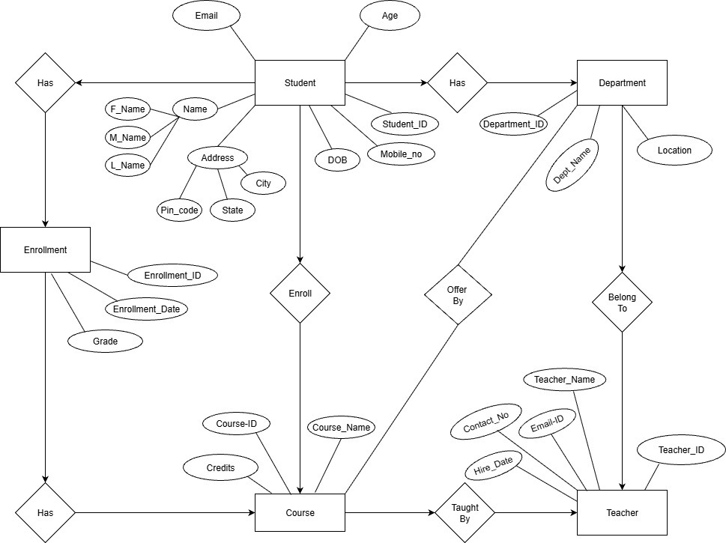

CREATE TABLE

Department Table

CREATE TABLE Department (
Department_ID INT PRIMARY KEY,
Dept_Name VARCHAR(100) NOT NULL,
Location VARCHAR(100)
);

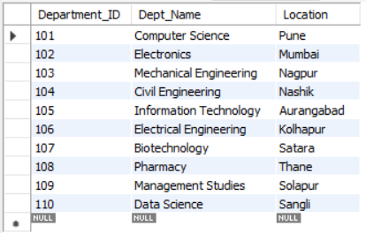

Student Table
CREATE TABLE Student (
Student_ID INT PRIMARY KEY,
F_Name VARCHAR(50),
M_Name VARCHAR(50),
L_Name VARCHAR(50),
Address VARCHAR(200),
City VARCHAR(50),
State VARCHAR(50),
Pin_code VARCHAR(10),
DOB DATE,
Age INT,
Mobile_no VARCHAR(15),
Email VARCHAR(100),
Department_ID INT,
FOREIGN KEY (Department_ID) REFERENCES Department(Department_ID)
);

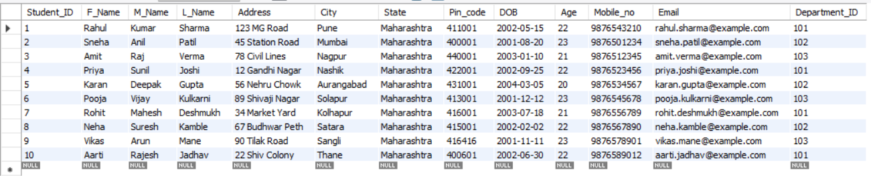

Teacher Table
CREATE TABLE Teacher (
Teacher_ID INT PRIMARY KEY,
Teacher_Name VARCHAR(100),
Contact_No VARCHAR(15),
Email_ID VARCHAR(100),
Hire_Date DATE,
Department_ID INT,
FOREIGN KEY (Department_ID) REFERENCES Department(Department_ID)
);
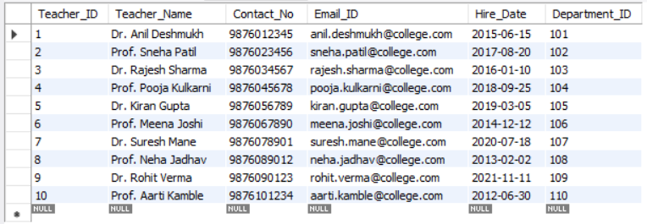

Course Table
CREATE TABLE Course (
Course_ID INT PRIMARY KEY,
Course_Name VARCHAR(100),
Credits INT,
Department_ID INT,
FOREIGN KEY (Department_ID) REFERENCES Department(Department_ID)
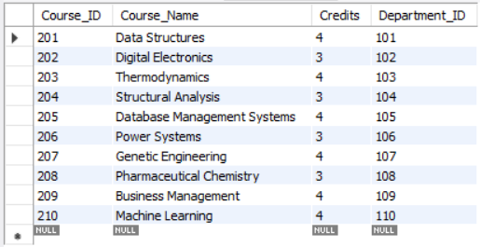
);

Enrollment Table
CREATE TABLE Enrollment (
Enrollment_ID INT PRIMARY KEY,
Student_ID INT,
Course_ID INT,
Enrollment_Date DATE,
Grade VARCHAR(5),
FOREIGN KEY (Student_ID) REFERENCES Student(Student_ID),
FOREIGN KEY (Course_ID) REFERENCES Course(Course_ID)
);

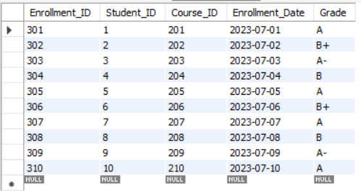

INSERT QUERIES
1) Inserting into Department
INSERT INTO Department (Department_ID, Dept_Name, Location) VALUES

(101, 'Computer Science', 'Pune'),

(102, 'Electronics', 'Mumbai'),

(103, 'Mechanical Engineering', 'Nagpur'),

(104, 'Civil Engineering', 'Nashik'),

(105, 'Information Technology', 'Aurangabad'),

(106, 'Electrical Engineering', 'Kolhapur'),

(107, 'Biotechnology', 'Satara'),

(108, 'Pharmacy', 'Thane'),

(109, 'Management Studies', 'Solapur'),

(110, 'Data Science', 'Sangli');

2) Inserting into Student

INSERT INTO Student (Student_ID, F_Name, M_Name, L_Name, Address, City, State, Pin_code, DOB, Age, Mobile_no, Email, Department_ID)
VALUES
(1, 'Rahul', 'Kumar', 'Sharma', '123 MG Road', 'Pune', 'Maharashtra', '411001', '2002-05-15', 22, '9876543210', 'rahul.sharma@example.com', 101),
(2, 'Sneha', 'Anil', 'Patil', '45 Station Road', 'Mumbai', 'Maharashtra', '400001', '2001-08-20', 23, '9876501234', 'sneha.patil@example.com', 102),
(3, 'Amit', 'Raj', 'Verma', '78 Civil Lines', 'Nagpur', 'Maharashtra', '440001', '2003-01-10', 21, '9876512345', 'amit.verma@example.com', 103),
(4, 'Priya', 'Sunil', 'Joshi', '12 Gandhi Nagar', 'Nashik', 'Maharashtra', '422001', '2002-09-25', 22, '9876523456', 'priya.joshi@example.com', 101),
(5, 'Karan', 'Deepak', 'Gupta', '56 Nehru Chowk', 'Aurangabad', 'Maharashtra', '431001', '2004-03-05', 20, '9876534567', 'karan.gupta@example.com', 102),
(6, 'Pooja', 'Vijay', 'Kulkarni', '89 Shivaji Nagar', 'Solapur', 'Maharashtra', '413001', '2001-12-12', 23, '9876545678', 'pooja.kulkarni@example.com', 103),
(7, 'Rohit', 'Mahesh', 'Deshmukh', '34 Market Yard', 'Kolhapur', 'Maharashtra', '416001', '2003-07-18', 21, '9876556789', 'rohit.deshmukh@example.com', 101),
(8, 'Neha', 'Suresh', 'Kamble', '67 Budhwar Peth', 'Satara', 'Maharashtra', '415001', '2002-02-02', 22, '9876567890', 'neha.kamble@example.com', 102),
(9, 'Vikas', 'Arun', 'Mane', '90 Tilak Road', 'Sangli', 'Maharashtra', '416416', '2001-11-11', 23, '9876578901', 'vikas.mane@example.com', 103),
(10, 'Aarti', 'Rajesh', 'Jadhav', '22 Shiv Colony', 'Thane', 'Maharashtra', '400601', '2002-06-30', 22, '9876589012', 'aarti.jadhav@example.com', 101);

3) Inserting into Department

INSERT INTO Department (Department_ID, Dept_Name, Location)
VALUES
(101, 'Computer Science', 'Pune'),
(102, 'Electronics', 'Mumbai'),
(103, 'Mechanical Engineering', 'Nagpur'),
(104, 'Civil Engineering', 'Nashik'),
(105, 'Information Technology', 'Aurangabad'),
(106, 'Electrical Engineering', 'Kolhapur'),
(107, 'Biotechnology', 'Satara'),
(108, 'Pharmacy', 'Thane'),
(109, 'Management Studies', 'Solapur'),
(110, 'Data Science', 'Sangli');

4) Inserting into Teacher

INSERT INTO Teacher (Teacher_ID, Teacher_Name, Contact_No, Email_ID, Hire_Date, Department_ID)
VALUES
(1, 'Dr. Anil Deshmukh', '9876012345', 'anil.deshmukh@college.com', '2015-06-15', 101),
(2, 'Prof. Sneha Patil', '9876023456', 'sneha.patil@college.com', '2017-08-20', 102),
(3, 'Dr. Rajesh Sharma', '9876034567', 'rajesh.sharma@college.com', '2016-01-10', 103),
(4, 'Prof. Pooja Kulkarni', '9876045678', 'pooja.kulkarni@college.com', '2018-09-25', 104),
(5, 'Dr. Kiran Gupta', '9876056789', 'kiran.gupta@college.com', '2019-03-05', 105),
(6, 'Prof. Meena Joshi', '9876067890', 'meena.joshi@college.com', '2014-12-12', 106),
(7, 'Dr. Suresh Mane', '9876078901', 'suresh.mane@college.com', '2020-07-18', 107),
(8, 'Prof. Neha Jadhav', '9876089012', 'neha.jadhav@college.com', '2013-02-02', 108),
(9, 'Dr. Rohit Verma', '9876090123', 'rohit.verma@college.com', '2021-11-11', 109),
(10, 'Prof. Aarti Kamble', '9876101234', 'aarti.kamble@college.com', '2012-06-30', 110);

5) Inserting into Course
INSERT INTO Course (Course_ID, Course_Name, Credits, Department_ID)
VALUES
(201, 'Data Structures', 4, 101),
(202, 'Digital Electronics', 3, 102),
(203, 'Thermodynamics', 4, 103),
(204, 'Structural Analysis', 3, 104),
(205, 'Database Management Systems', 4, 105),
(206, 'Power Systems', 3, 106),
(207, 'Genetic Engineering', 4, 107),
(208, 'Pharmaceutical Chemistry', 3, 108),
(209, 'Business Management', 4, 109),
(210, 'Machine Learning', 4, 110);
6) Inserting into Enrollment
INSERT INTO Enrollment (Enrollment_ID, Student_ID, Course_ID, Enrollment_Date, Grade)
VALUES
(301, 1, 201, '2023-07-01', 'A'),
(302, 2, 202, '2023-07-02', 'B+'),
(303, 3, 203, '2023-07-03', 'A-'),
(304, 4, 204, '2023-07-04', 'B'),
(305, 5, 205, '2023-07-05', 'A'),
(306, 6, 206, '2023-07-06', 'B+'),
(307, 7, 207, '2023-07-07', 'A'),
(308, 8, 208, '2023-07-08', 'B'),
(309, 9, 209, '2023-07-09', 'A-'),
(310, 10, 210,'2023-07-10', 'A');

SELECT QUERY

- From Department

SELECT *
FROM department
WHERE DEPARTMENT_ID IS NOT NULL;
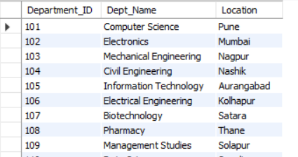

2) From Student
SELECT *
FROM Student
WHERE City = 'Pune';

DELETE QUERIES

1)Delete one student record
DELETE FROM Student
WHERE Student_ID = 10;
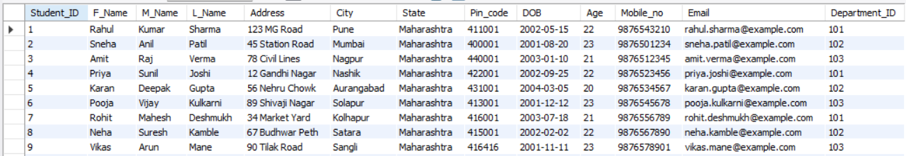

2)Delete one Department record
DELETE FROM Department
WHERE department_id = 110;

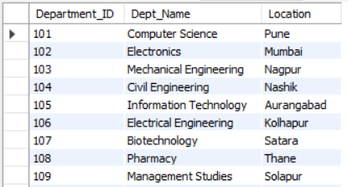

UPDATE QUERIES

Update student’s city
UPDATE Student
SET City = 'Mumbai'
WHERE Student_ID = 1;

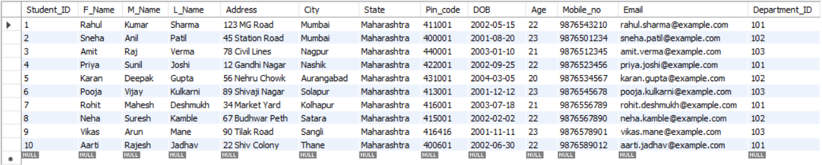

TRUNCATE QUERIES

1)
TRUNCATE TABLE Enrollment;

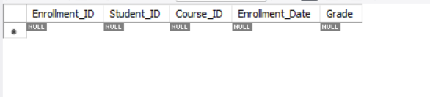

2)
TRUNCATE TABLE department;

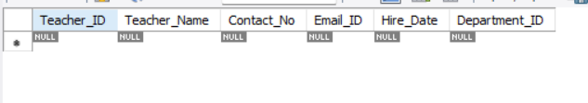

JOIN QUERY

1) INNER JOIN
SELECT
S.Student_ID,
CONCAT(S.F_Name, ' ', S.L_Name) AS Student_Name,
D.Dept_Name
FROM
Student S
INNER JOIN
Department D
ON
S.Department_ID = D.Department_ID;

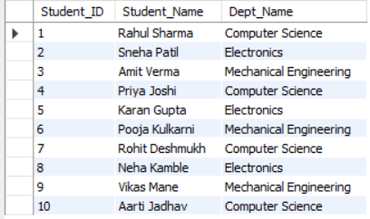

2) Left Join

SELECT
S.Student_ID,
CONCAT(S.F_Name, ' ', S.L_Name) AS Student_Name,
E.Course_ID,
E.Grade
FROM
Student S
LEFT JOIN
Enrollment E
ON
S.Student_ID = E.Student_ID;

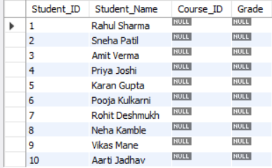

3) RIGHT JOIN

SELECT
C.Course_Name,
S.F_Name AS Student_Name,
E.Grade
FROM
Enrollment E
RIGHT JOIN
Course C
ON
E.Course_ID = C.Course_ID
LEFT JOIN
Student S
ON
E.Student_ID = S.Student_ID;

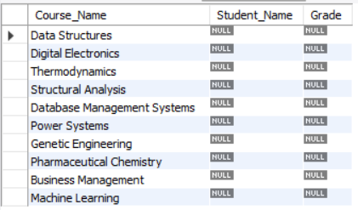

4) FULL JOIN
SELECT S.Student_ID, S.F_Name, C.Course_Name
FROM Student S
LEFT JOIN Enrollment E ON S.Student_ID = E.Student_ID
LEFT JOIN Course C ON E.Course_ID = C.Course_ID
UNION
SELECT S.Student_ID, S.F_Name, C.Course_Name
FROM Student S
RIGHT JOIN Enrollment E ON S.Student_ID = E.Student_ID
RIGHT JOIN Course C ON E.Course_ID = C.Course_ID;

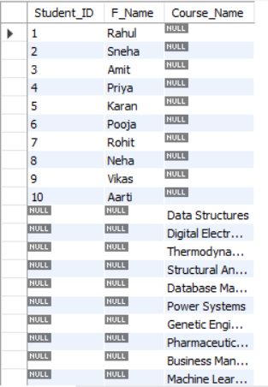

CONCLUSION

The Student Management System is an efficient database management solution designed to handle and organize student-related data systematically. It simplifies various academic and administrative tasks such as student registration, record maintenance, and attendance tracking. By using a structured database, the system ensures data accuracy, consistency, and easy retrieval of information.

This project demonstrates the practical application of DBMS concepts like data normalization, relationships, queries, and data integrity. It minimizes manual effort, reduces paperwork, and improves the overall efficiency of educational institutions. In conclusion, the Student Management System provides a reliable, user-friendly, and scalable platform for managing student information effectively.

